Versie: 28 juni 2024
BRISTELL BR23 CHECKLIST 1
Before Engine Start

Preflight/Daily inspection COMPLETED
Passenger briefing……… COMPLETED
Papers / Map…………....... CHECKED/ON BOARD
Loose objects……………. SECURED
Circuit breakers …….…… CHECK ALL IN
Master Switch ……………. ON
Backup Battery…………… ON
EFIS switch……………….. ON
Seat Belts ………………… FASTEN
Rudder pedals………….… ADJUSTED/SECURED
Flight Controls ……….….. FULL / FREE AND CORRECT
Trims ……………………… SET elevator and aileron
Fuel Caps…………………. SECURED
Wing Lockers…………….. CLOSED & LOCKED
Canopy…………………….. CLOSED & LOCKED
Parking brake…………….. ON
Altimeter …………………... SET PFD
PFD…………………………. Set split (PFD and EMS)
Fuel quantity……………… CHECK/SET ON EMS
Weight & Balance……….. SET/CHECK Limits

Versie: 28 juni 2024
2 BRISTELL BR23 CHECKLIST
Engine Start

Fuel selector……………… LEFT TANK
Fuel pump ………………… ON
Choke ……………………... AS NEEDED
Prop control……. ………… FULL FORWARD
Throttle ……………………. JUST OPEN
Strobe Light………………. ON
Start Engine ……………… TURN KEY TO START
Oil Pressure ……………… CHECK 2-7 BAR
Engine RPM ………….…… 2000 RPM FOR WARMING UP (OIL < 50°C)
Choke ……………………... GRADUALLY RELEASE
Before Taxiing
After Engine Start

Backup Battery…………… OFF
Fuel pump ………………… OFF
Avionic switch …………. ON Check minimum 11.0V
ALT-1 switch……………... ON Check increase to 13.4V
ALT-2 switch……………... ON Check increase to 13.8V
Engine Limits:
Speed 5500 - 5800 rpm (5 min.)
5500 rpm (continuous)
Cyl. Head Temp. 90° – 135° C (135°C max.)
Oil Temp. 90°C - 110°C (130°C max.)
Exh. Gas Temp. 880°C max..
Oil Pressure 2 - 5 bar (7 bar max. cold eng.)
Fuel Pressure 0,15 – 0,4 bar

Versie: 28 juni 2024
BRISTELL BR23 CHECKLIST 3
Before Taxiing

Cockpit lights…………….. AS REQUIRED
Nav lights ………………… ON
Parachute ………………… SAFETY PIN REMOVED
Wind direction …………... CHECK (For runway in use)
Transponder……………… Set to 7000
Oil Temp ………………….. MIN. 30°C
Time ……………………….. CHECK (Start flight timing)
Radio call ………………… APPLY
Parking Brake …………… RELEASE / CHECK BRAKES

Versie: 28 juni 2024
4 BRISTELL BR23 CHECKLIST
ENGINE RUN-UP

Parking brake ……………. ON
Fuel selector …………….. RIGHT TANK
Engine instruments …….. CHECK, WITHIN LIMITS
Prop control……. ………… FULL FORWARD
Ignition Check ………….... THROTTLE 4000 RPM
Test Ignition ………….….. Drop MAX.300 diff 115 rpm
Carburetor Heat …….…... PULL HOT, Check drop MIN. 150 RPM, PUSH OFF
Prop control………………. CYCLE 2 times at 4500 RPM, Check drop > 200 rpm
Prop control……..………… FULL FORWARD
Engine instruments …….. CHECK OIL & FUEL PRESS
Throttle ………………….… IDLE (1700-2000 RPM)
Fuel Selector……………… LEFT TANK
Fuel pump………………… ON, check pressure
BEFORE TAKEOFF

Flaps ………………….…… SET 10° (stage 1)
Altimeter ……….…............ CHECK BOTH
Instruments …………….... CHECK WITHIN LIMITS
Canopy …………………..... CHECK CLOSED & LOCKED
Seat Belts ………………… FASTEN
Landing Light……………. ON
PFD………………………… FULL SCREEN

Versie: 28 juni 2024
BRISTELL BR23 CHECKLIST 5
TAKEOFF

Wind……………………...… CHECK
Brakes……………………… RELEASE
Throttle ……………………. MAX (Min. 5500 RPM)
Airspeed indication……… CHECK “ALIVE”
Initial climb……………….. 64 KIAS (Vx)
CLIMB
> 100 ft: Prop control….. < 5500 RPM
> 150 ft: Flaps…………… UP
Climb speed ……………… 74 KIAS

Level off
Manifold Pressure…….… 26-26,5 Inch
Prop control……………… 4800-4850 RPM
Fuel pump…………………. OFF
Engine Instruments …….. CHECK WITHIN LIMITS
APPROACH

Brakes …………………….. OFF / CHECK PRESSURE Seat belts ……………….… FASTEN
Autopilot…………………… DISENGAGE
PFD ………………………… FULL SCREEN
Engine Instruments …….. CHECK WITHIN LIMITS
Landing Light ……………. ON
Fuel Pump ………………... ON check pressure and QTY
Carburetor heat .………… PULL HOT (if applicable)
Throttle……………………. 21-15 Inch
Prop control……………… 4800-4850 RPM
Fuel Selector……………… FULLEST TANK

Versie: 28 juni 2024
6 BRISTELL BR23 CHECKLIST
LANDING

Airspeed…………………… 75 KIAS
Flaps ………………………. SET 10° (stage 1)
Airspeed…………….….…. 70 KIAS
Airspeed…………….….…. 65 KIAS
Flaps ………………………. SET 25° (stage 2)
Airspeed…………………… 60 KIAS
On Final: Propeller…,,,,.… FULL FORWARD

AFTER LANDING

Throttle…………………….. As required for taxi
Carburetor Heat ..………. OFF
Flaps ………………………. UP
Fuel Pump ………………... OFF
Landing Light ……………. As required

AIRCRAFT PARKING

Parking Brake ……………. SET
Prop control……………….. CHECK FULL FORWARD
Throttle …………………… IDLE
Trims ………………………. SET TO NEUTRAL
Instruments ……………… CHECK WITHIN LIMITS
Time ………………………. CHECK (Stop flight timing)
Ignition Switch ………….. TURN KEY OFF & REMOVE

Versie: 28 juni 2024
BRISTELL BR23 CHECKLIST 7

Lights……………………… OFF
EFIS…..……………………. OFF
Avionics Switch …..…….. OFF
Alt-2 and Alt-1……………. OFF
Master switch……………. OFF
Fuel Selector…………….. OFF
Parachute ………………… SAFETY PIN IN

Performance data for variable pitch propellor

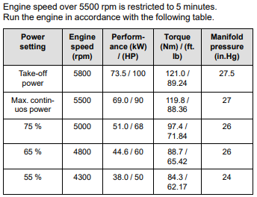
Versie: 28 juni 2024
8 BRISTELL BR23 CHECKLIST
AIRCRAFT LIMITS
V_{NE} never exceed 157 KTS
V_{A} maneuvering 99 KTS
V_{no} Max cruising speed 136 KTS
V_{fe} 82 KTS
V_{X} best angle climb 62 KTS
V_{Y} best rate climb 74 KTS
Cruise climb 75 KTS
V_{s1} stall clean 51 KTS
V_{so} full flaps 44 KTS
Best glide speed 67 KTS
Max. dem. crosswind 15 KTS

G-limits flaps up +4 / -2
G-limits flaps down +2 / 0

Empty weight 448 KG
Max baggage weight wings 2x20 KG Max baggage behind the seats 28 KG
Max. T/O weight 750 KG
Max Forward CG Limit 25% MAC
Max AFT CG Limit 31% MAC

Bristell EMERGENCY Procedures

ENGINE FAILURE DURING T/O RUN .
Throttle ………………….. IDLE
Brakes …………………... APPLY
Ignition ………………….. OFF

ENGINE FAILURE AFTER TAKEOFF .
Airspeed ………………… 67 KNOTS
Flaps …………………….. AS NECESSARY
Fuel Selector …………... OFF
Ignition Switch ………… OFF
Master switch ………….. OFF
Land straight ahead, turning only to avoid obstacles

LOSS OF ENGINE POWER IN FLIGHT .
Speed ………………..….. 67 KIAS
Inflight Engine Restart … APPLY
OR PERFORM EMERGENCY LANDING

EMERGENCY DESCENT .
Airspeed ………………… MAX PERMITTED:
V_{NE} = 157 KIAS
V_{no} = 136 KIAS
V_{A} = 99 KIAS
Engine RPM ……………. MAX. 5800 RPM

Bristell EMERGENCY Procedures

ENGINE FIRE DURING T/O RUN .
Throttle ……………... IDLE
Fuel Selector ………. OFF
Fuel Pump …………. OFF
Cabin Heating ……… OFF
Brakes ……………… APPLY AS NEEDED
When airplane is under control:
Ignition ……………… TURN KEY OFF
Master ……………. …OFF
Parking Brake ……… SET
Evacuate the aircraft!
ENGINE FIRE IN-FLIGHT .
Cabin Heat ………… PUSH OFF
Fuel Selector ……… OFF
Throttle …………….. MAX
Ignition Switch ……. OFF AFTER ENGINE STOPS
Airspeed …………… EMERGENGY DECENT
Master Switch …….. OFF
Perform emergency landing!
Evacuate the aircraft!
COCKPIT FIRE ………………….
Master Switch …….. OFF
Cabin Heating ……… OFF
Ventilation …………. OPEN

PERFORM EMERGENCY LANDING AS SOON AS POSSIBLE
Bristell EMERGENCY Procedures

IN-FLIGHT ENGINE RESTART .
Airspeed…………………… 75 KIAS
Fuel Pump ………………... ON
Fuel Selector …………….. FULLEST TANK
Throttle ……………………. JUST OPEN
Carburetor Heat …….…... PULL HOT
Ignition Switch …………… TURN KEY
After engine is running
Engine instruments …….. CHECK, WITHIN LIMITS
Avionics ………………….. ON
Fuel Pump ……………….. OFF

EMERGENCY LANDING WITHOUT ENGINE POWER
Airspeed ………………..….. 67 KIAS
Locate suitable terrain without obstacles
Propeller control ………… FINE PITCH (fully Forward)
Trim…………………………. Adjust
Seat Belts ………………… Tighten
Landing Light……………. ON
Flaps ……………………… Extend as needed
Radio call ………………… Apply (MAYDAY)
Transponder ……………... Set 7700
Approach …………........... WITHOUT STEEP TURNS
Fuel Selector……………... OFF
Before Touchdown
Master Switch………... OFF
Bristell EMERGENCY Procedures

POWER-ON FORCED LANDING .
A precautionary landing is generally carried out in the cases where the pilot may be disorientated, the aircraft has no fuel reserve or possibly in bad weather conditions.
1. Choose landing area, determine wind direction.
2. Report your intention to land and landing area location.
3. Perform low-altitude passage into wind over the right-hand side of the
chosen area with flaps extended as needed and thoroughly inspect the
landing area.
4. Perform circle pattern.
5. Seat belts - fasten
6. Perform approach at increased idling with flaps in landing position (25°) at
67 KIAS.
7. Reduce power to idle when flying over the runway threshold and
touch-down at the very beginning of the chosen area.
8. After stopping the airplane:
Ignition Switch……………………. TURN KEY OFF & REMOVE
ALL Switches……………………... OFF
FUEL selector…………………….. OFF
Airplane ……………………………. lock and seek assistance

RECOVERY FROM UNINTENTIONAL SPIN .
Power ………………. IDLE
Flaps ……………….. RETRACT
Ailerons ……………. NEUTRAL
Rudder …………….. FULL OPPOSITE
Elevator ……………. PUSH FORWARD
HOLD THESE INPUTS UNTIL THE ROTATION STOPS THEN:
Rudder ……………… NEUTRAL
Elevator …………….. PULL GENTLY TO
RECOVER FROM DIVE

Bristell Pre-flight Inspection

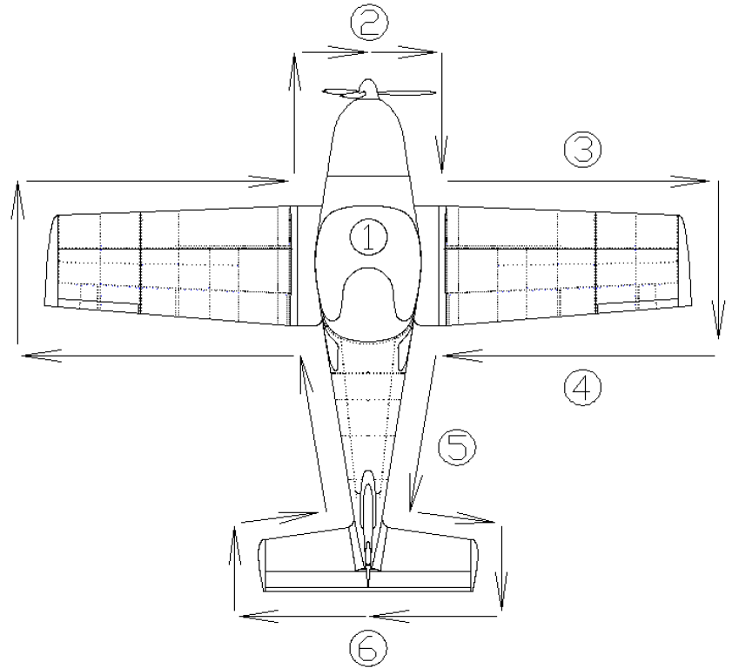
1) Ignition ………………….….. OFF
Avionics/Instruments ……… Check condition
Cockpit ……………………… Check for loose items and condition
Master switch ……………… ON
Avionics switch……………… ON
Fuel quantity indication ……. Compare visual with indication
Flaps …………..…………….. Check operation
Lights ………………………… Check operation
Pitot tube heating …………… Check function
All switches …………………. OFF
Control System……………… Check function, free movement
Canopy……………………….. Condition of attachment, cleanness
Bristell Pre-flight Inspection

2) Engine cowling condition
Propeller, blades and spinner condition
Oil quantity check
Coolant quantity check
Engine mount and exhaust manifold condition
Inlets free of obstruction
Fuel system draining / gascollator
Nose gear condition

3) Wing surface condition
Leading edge condition
Stall strips condition
Wing locker, Closed and locked
Pitot free of obstruction
Fuel vent openings

4) Wing tip, surface condition, attachment
Lichts, condition attachment
Aileron, surface condition, attachment
Flap, surface condition, attachment
Wing locker, Closed and locked
Fuel caps, in place en closing
Pitot free of obstruction
Fuel vent openings

5) Landing gear, check for condition and damage
Weel attachment, brakes condition and pressure tires
Wing lower surface and fuselage bottom surface condition
Static port free of obstructions

6) - Vertical Tail Unit Condition of Surface, Attachment free rudder Movement, (press tail down to have nosegear free) antenna.
- Horizontal Tail Unit Condition of surface, Attachment, free elevator movement elevator tips and mass balance.
- Check trim/anti-servo tab
- Check free movement of tab for full elevator movement

